Week 9 Report: Intelligent Detection

Name: Swayam Rudrawar

1. Objective:
Develop an intelligent light monitoring system capable of classifying ambient light conditions and detecting high-intensity events in real time using a trained Machine Learning model. Deploy the trained model in a Streamlit dashboard for live monitoring.

2. Topics Covered:
- Threshold-based and Machine Learning-based detection
- Real-time decision making
- Decision Tree model deployment
- Streamlit dashboard development
- Live data visualization
- System responsiveness and event logging

3. Software and Tools:
Tool | Purpose
Python | Model execution
Scikit-learn | Decision Tree prediction
Pandas | Dataset handling
Streamlit | Interactive dashboard
Plotly | Real-time graph
Joblib | Loading trained model
VS Code | Development

4. Methodology:
- Loaded the trained Decision Tree model (.pkl).
- Loaded the combined sensor dataset containing Lux and Smoothed Lux values.
- Predicted the light class (Bright, Dim, Dark) for each incoming sample.
- Applied threshold-based anomaly detection (Lux ≥ user-defined threshold).
- Displayed live sensor readings, prediction time, event counter, and prediction result.
- Visualized the incoming data using a continuously updating Plotly graph.
- Logged all detected high-intensity events in an event history table.

5. Intelligent Detection Demo:
The dashboard continuously streams sensor readings from the recorded dataset to simulate live operation. Every sample is classified by the deployed Decision Tree model. Whenever the Lux value exceeds the selected threshold, the system immediately raises a High Intensity Detected event and stores the event in the history table.

6. Results:
Figure 1. Live Monitoring Dashboard
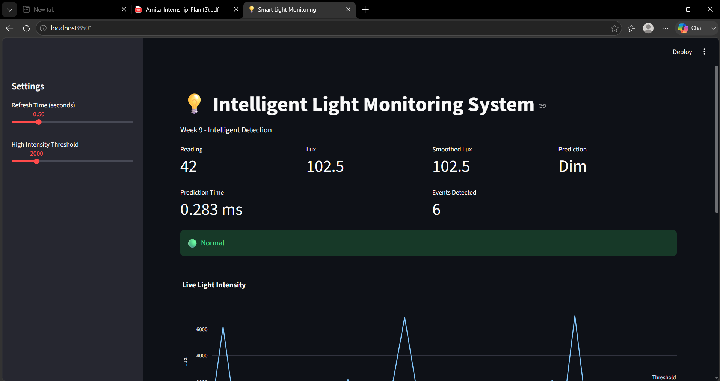
Figure 2. Event History showing detected high-intensity events
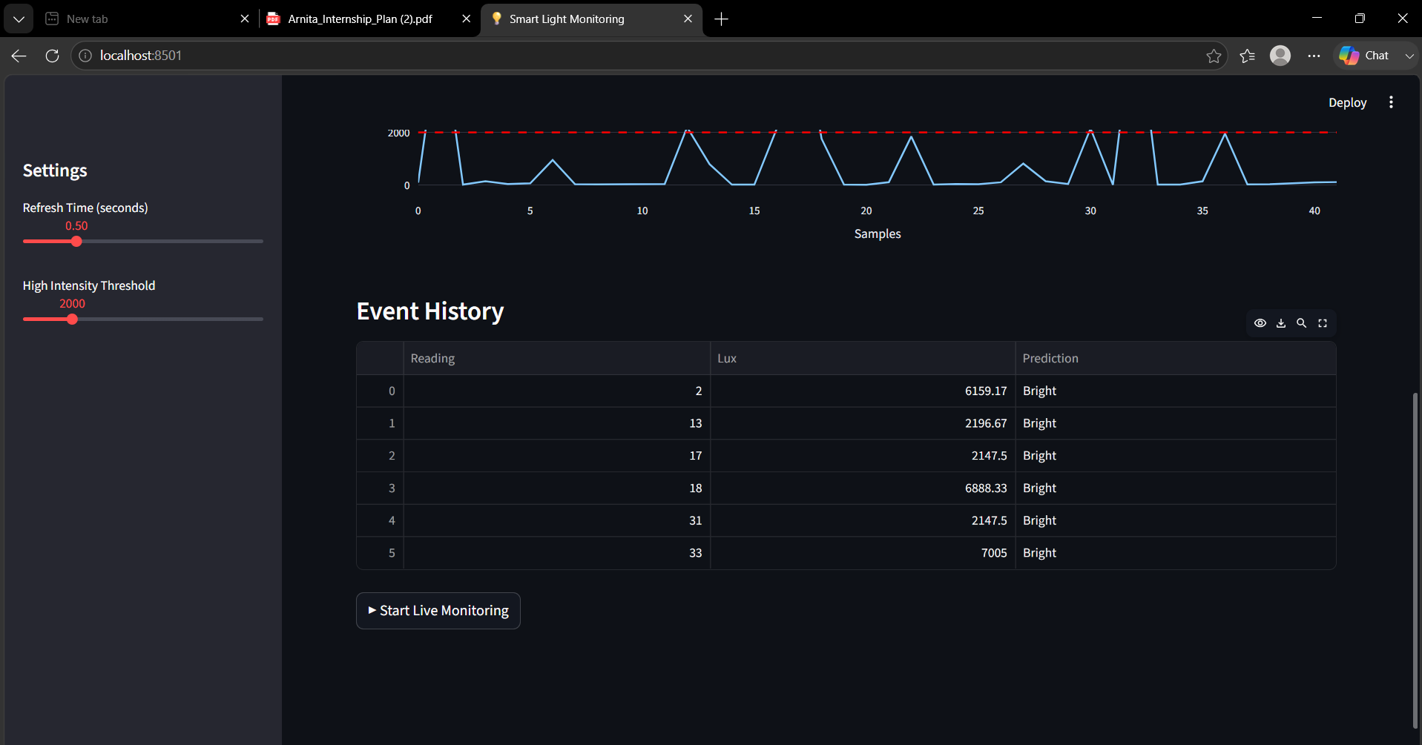

7. Model Deployment Documentation:
The trained Decision Tree model was exported using Joblib and loaded into the Streamlit application. The dashboard performs inference using the Lux and Smoothed Lux features, updates predictions in real time, visualizes incoming data, measures prediction latency, and logs abnormal events. The application can be deployed locally using 'streamlit run app.py' or hosted on Streamlit Community Cloud by connecting the project repository to GitHub.

8. Conclusion:
The Week 9 objective was successfully achieved. A trained Machine Learning model was deployed into a real-time monitoring application capable of classifying light intensity and detecting abnormal high-intensity events. The dashboard demonstrates practical intelligent detection with live visualization, low prediction latency, and automatic event logging.

